EC2- ELASTIC COMPUTE CLOUD
Objectives-
- To learn how to launch and configure virtual servers in the cloud.
- To understand cloud computing and AWS infrastructure services.
- To create and manage EC2 instances using AWS Management Console.
- To configure security groups and key pairs for secure access.
- To connect EC2 instances using SSH or Remote Desktop.
- To host applications or websites on cloud servers.
- To monitor instance performance and resource usage.
- To understand scalability, flexibility, and cost-effective cloud deployment.
Step 1- Search EC2 on AWS Console , then open dashboard.
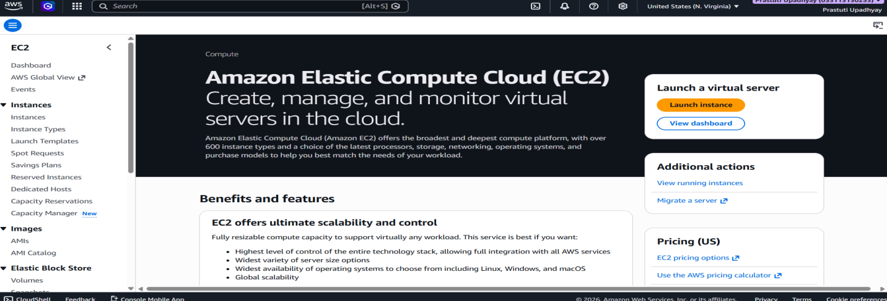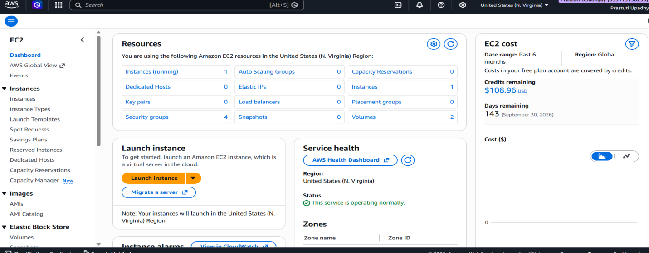
Step 2- Launch Instance in dashboard.
• Select AMI (Amazon Machine Image): Choose Amazon Linux 2023 AMI as the operating system.
• Choose Instance Type: Select t3.micro (Free Tier eligible) as the instance type.
• Set Number of Instances: Keep the default value as 1.
• Configure Security Group: Create a new security group to control inbound/outbound traffic.
• Configure Storage: Keep the default storage as 8 GiB.
• Review Summary: Verify all selected settings in the Summary panel.
• Launch Instance: Click the Launch instance button to create and start the EC2 instance.
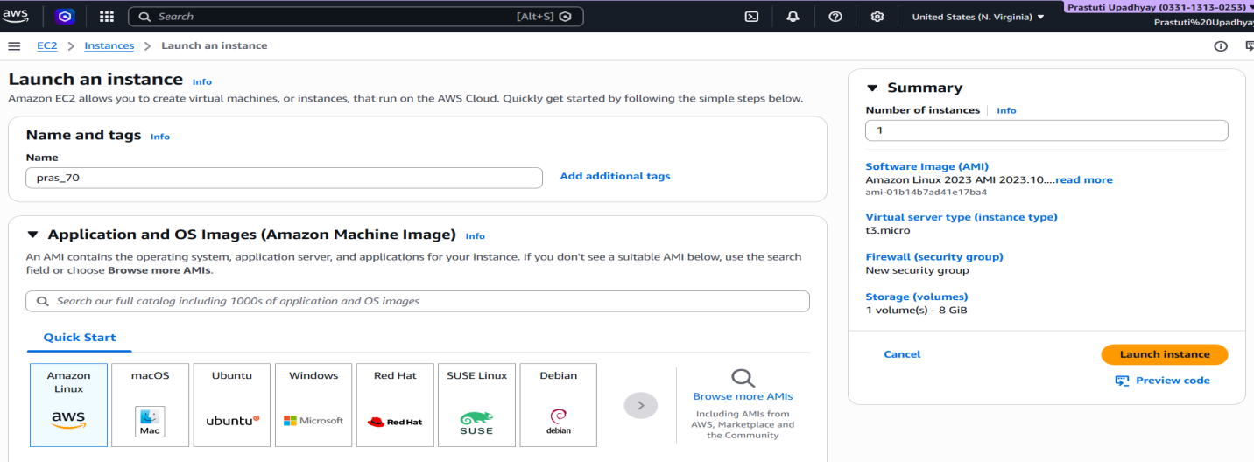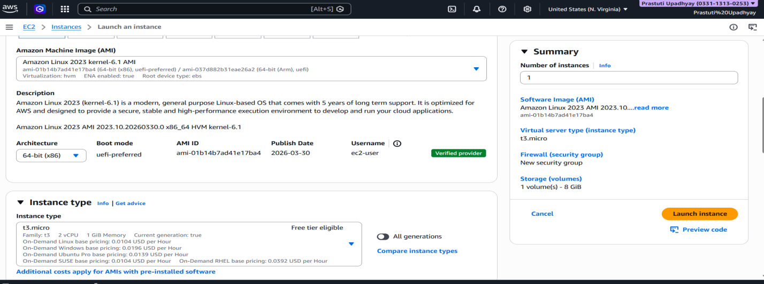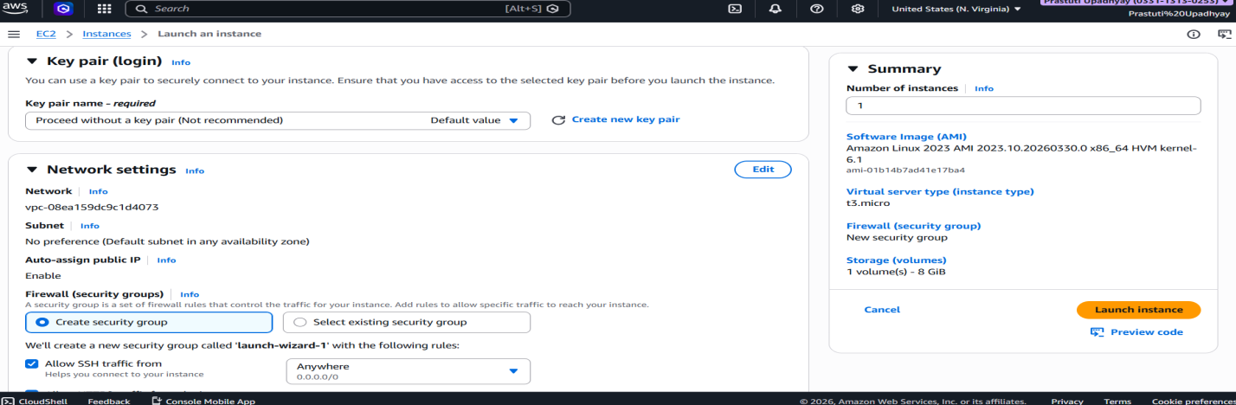

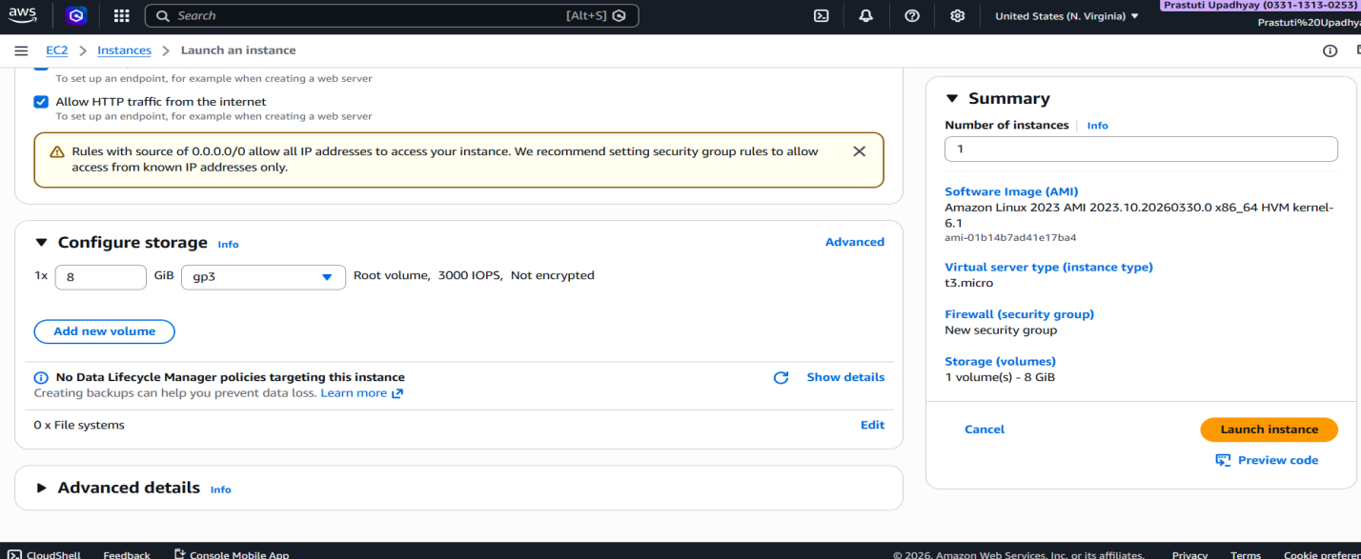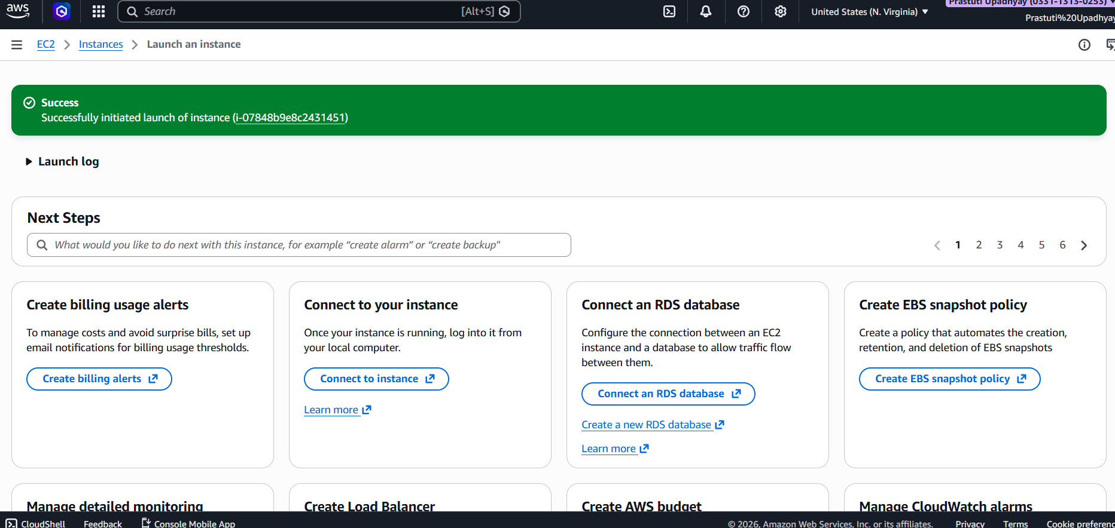
Step 3- Create Volume.
• Go to EC2 → Volumes → Create Volume.
• Set Volume type = gp3, Size = 8 GiB.
• Keep defaults → IOPS = 3000, Throughput = 125 MiB/s.
• Select Availability Zone = us-east-1a.
• Skip Snapshot ID (no snapshot).
• Optional → Add Encryption / Tags.
• Click "Create Volume".
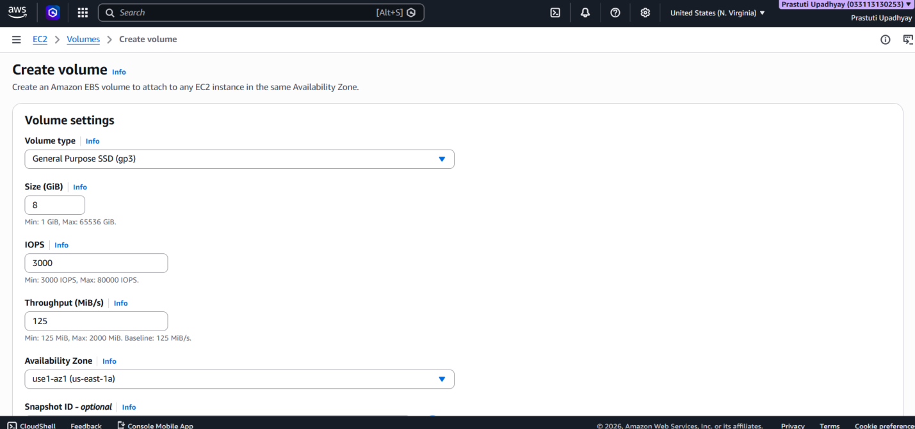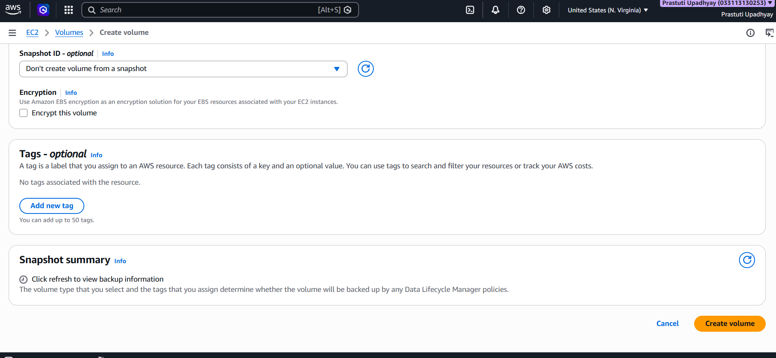
Step 4- Connect to EC2 Instance.
• Go to EC2 → Instances → Select your instance → Click "Connect".
• Choose tab → EC2 Instance Connect.
• Connection type → Select "Connect using Public IP".
• IP shown → 3.86.41.9 (Public IPv4).
• Username → Keep default as ec2-user.
• Click orange "Connect" button.
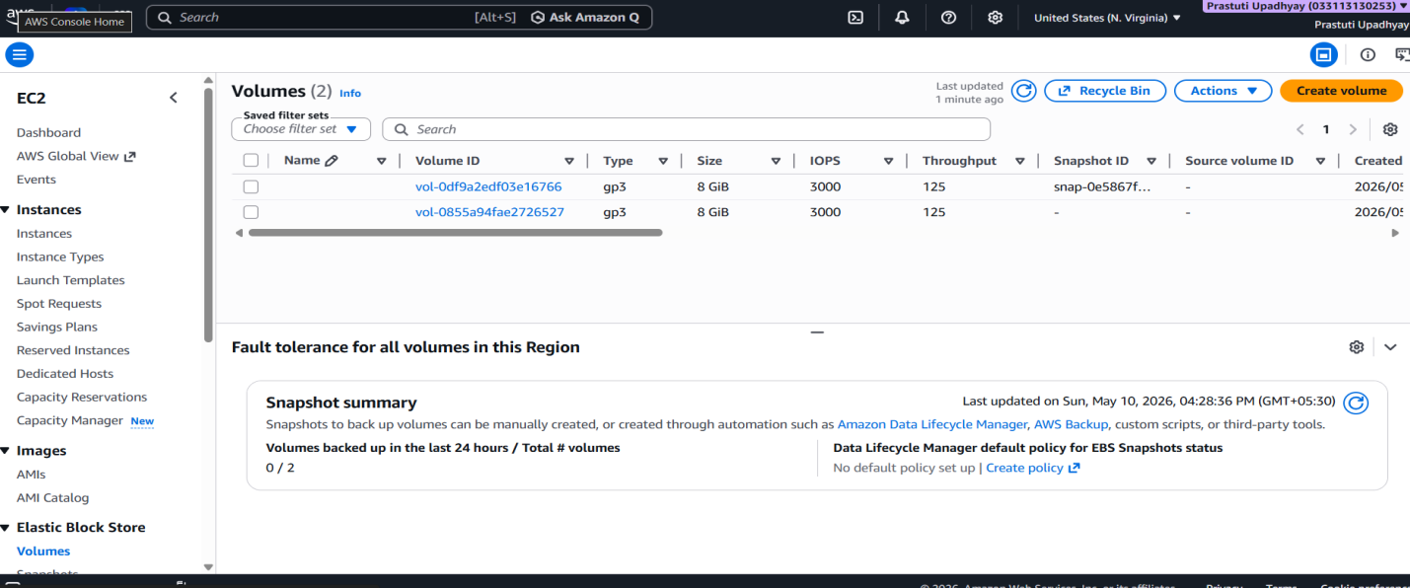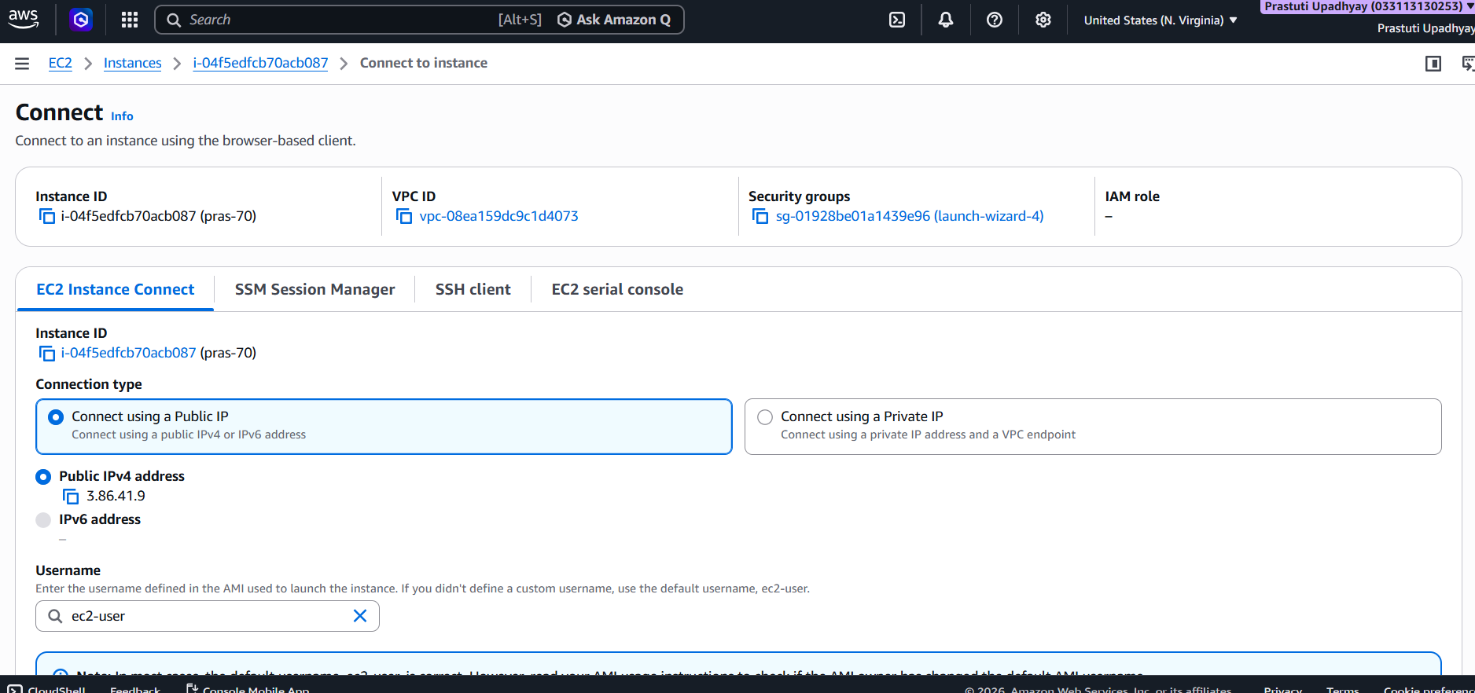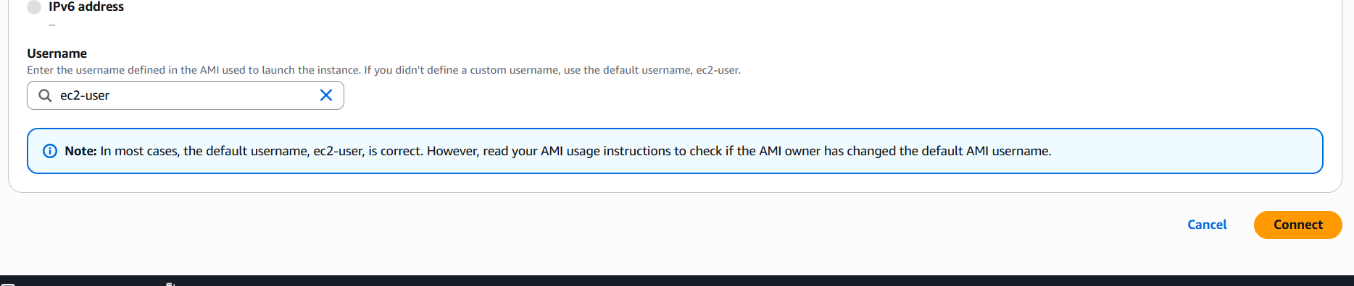
Step 5-
• pwd → Check current location → /home/ec2-user.
• mkdir prasti → Created a new folder named prasti.
• cd prasti/ → Moved inside the folder.
• vim hello.txt → Created & opened a text file.
• (Typed "Hello" → saved & exited vim).
• cat hello.txt → Displayed file content → showed "hello".
• exit → Logged out of the instance.
